|  |
| --- |
|  |
| 新概念 3 册 |
| Lesson46 Do it yourself |

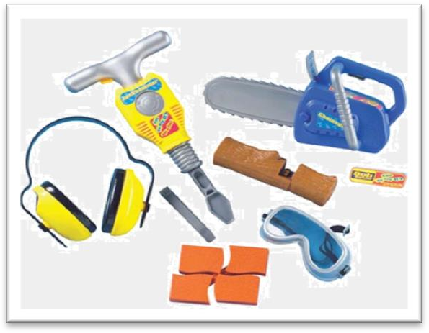

Book

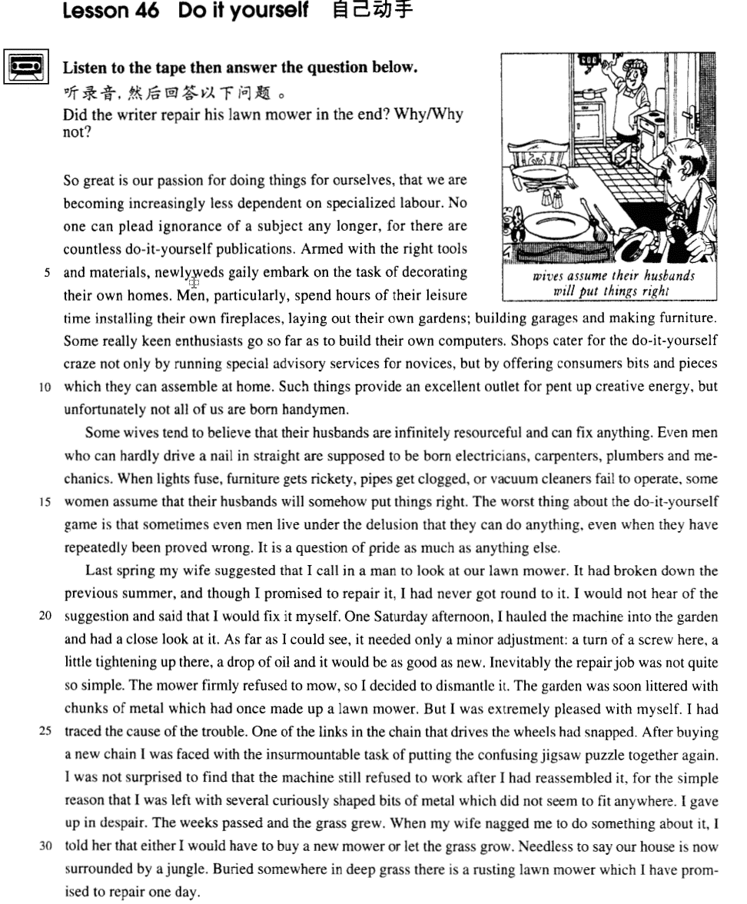

课文

So great is our passion for doing things for ourselves, that we are becoming increasingly less dependent on specialized labour.

现在我们自己动手做事的热情很高，结果对于专业工人的依赖越来越少了。

No one can plead ignorance of a subject any longer, for there are countless do-it-yourself publications.

由于出版了不计其数的教人自己动手做事的书报杂志，没有人再能说对某事一无所知。

Armed with the right tools and materials, newlyweds gaily embark on the task of decorating their own homes.

新婚夫妇找来合适的工具和材料，喜气洋洋地开始布置新房。

Men, particularly, spend hours of their leisure time installing their own fireplaces, laying out their own gardens; building garages and making furniture. Some really keen enthusiasts go so far as to build their own computers.

特别是男人，常利用空闲时间安装壁炉、布置花园、建造车库、制作家具。有些热衷于自己动手的人甚至自己组装电脑。

Shops cater for the do-it-yourself craze not only by running special advisory services for novices, but by offering consumers bits and pieces which they can assemble at home.

为了满足自己动手热的需要，商店不仅为初学者提供专门的咨询服务，而且为顾客准备了各种零件，供他们买回家去安装。

Such things provide an excellent outlet for pent up creative energy, but unfortunately not all of us are born handymen.

这些东西为人们潜在的创造力提供了一个绝妙的用武之地。但不幸的是，我们并非人人都是能工巧匠。

Some wives tend to believe that their husbands are infinitely resourceful and can fix anything.

妻子常常认为她们的丈夫无比聪明能干。

Even men who can hardly drive a nail in straight are supposed to be born electricians, carpenters, plumbers and mechanics.

甚至那些连一枚钉子都钉不直的男人都被认为是天生的电工、木匠、水管工和机械师。

When lights fuse, furniture gets rickety, pipes get clogged, or vacuum cleaners fail to operate, some women assume that their husbands will somehow put things right.

每当电灯保险丝烧断、家具榫头松动、管道堵塞、吸尘器不动时，有些妻子认为丈夫总有办法。

The worst thing about the do-it-yourself game is that sometimes even men live under the delusion that they can do anything, even when they have repeatedly been proved wrong.

自己动手的例子中最糟糕的是，有时甚至是男人尽管接连失败却还误以为自己什么都行，

It is a question of pride as much as anything else.

原因就是要面子。

Last spring my wife suggested that I call in a man to look at our lawn mower.

今年春天，妻子让我请人检查一下我家的割草机。

It had broken down the previous summer, and though I promised to repair it, I had never got round to it.

那台割草机去年夏天就坏了，尽管我答应修，但一直没抽出时间，

I would not hear of the suggestion and said that I would fix it myself.

我不愿听妻子的建议，说我自己会修。

One Saturday afternoon, I hauled the machine into the garden and had a close look at it.

一个星期六的下午，我把割草机拉到了花园里，仔细检查了一番。

As far as I could see, it needed only a minor adjustment: a turn of a screw here, a little tightening up there, a drop of oil and it would be as good as new.

在我看来，只需稍加调整即可，这儿紧紧螺丝，那儿固定一下，再加几滴油，就会像新的一样了。

Inevitably the repair job was not quite so simple.

事实上，修理工作远不是那么简单。

The mower firmly refused to mow, so I decided to dismantle it.

修完后割草机还是纹丝不动。于是，我决定把它拆开。

The garden was soon littered with chunks of metal which had once made up a lawn mower.

一会儿工夫，割草机便被拆成一个个金属零件，乱七八糟地堆在花园里。

But I was extremely pleased with myself.

但我却非常高兴，

I had traced the cause of the trouble.

因为我找到了毛病所在。

One of the links in the chain that drives the wheels had snapped.

驱动轮子的链条断了一节。

After buying a new chain I was faced with the insurmountable task of putting the confusing jigsaw puzzle together again.

我买来一根新链条后，面临的就是如何把这些令人眼花缭乱的拼板重新组装起来。

I was not surprised to find that the machine still refused to work after I had reassembled it, for the simple reason that I was left with several curiously shaped bits of metal which did not seem to fit anywhere.

等我装完后，那台割草机仍然一动不动，对此我倒并不感到吃惊，原因很简单，因为还剩下几个形状奇特的零件似乎哪里也装不上去。

I gave up in despair.

我无可奈何，只好罢休。

The weeks passed and the grass grew.

几个星期过去了，草长了起来。

When my wife nagged me to do something about it, I told her that either I would have to buy a new mower or let the grass grow.

妻子喋喋不休让我想点办法。我告诉她，要么买一台新割草机，要么让草长下去。

Needless to say our house is now surrounded by a jungle.

不用说，我家现在已被丛林包围。

Buried somewhere in deep grass there is a rusting lawn mower which I have promised to repair one day.

深草丛中的某个地方有一台正在生锈的割草机，那就是我曾答应某日要修理的割草机。

词汇讲解

* **plead** [pli:d] v. 以某事为借口

**plead** **pleaded**（过去式） **pleaded**（过去分词）

**plead** **pled**（过去式） **pled**（过去分词）

* **plead** ignorance（不知道） / illness（生病） / a headache（头疼） / tiredness（疲劳） / insanity（精神失常） 以…为借口
* Ellie **pleaded tiredness** and went to bed very early.
* **6级真题：**
* He could not ­­­­___A___ ignorance as his excuse; he should have known what was happening in his department.

(A) **plead**

(B) resort

(C) petition

(D) reproach

**plead for sth.** （不及物）恳求得到某个东西

* He knelt in front of the king, **pleading for mercy**.

**plead with sb. to do sth.** 恳求某人做某事

* I **pleaded with him to stay**, but he turned his back on me.
* **ignorance** ['ɪgnərəns] n. 无知，不知道（贬义，应该知道而不知道）
* **Ignorance** is bliss. 无知是福

**be ignorant of ...** 不知道某事（贬义，应该知道而不知道）

* **阅读真题：**
* Darwin had a phrase to describe those **ignorant of** evolution: they “look at an organic being as a savage looks at a ship, as at something wholly beyond his comprehension.”

**【同根词】**

**ignore** v. 忽视；对 … 不予理会（主动）

**【近义词】**

**neglect** v. 疏于照顾；未予看管（客观）

* When I saw Jane, I stopped and smiled, but she ­­­­___B___ me and walked on.

(A) refused

(B) **ignored**

(C) denied

(D) missed

* The joys of travel, having long­­­­ ___C___ the disabled, are opening up to virtually anyone who has the means.

(A) omitted

(B) missed

(C) **neglected**

(D) discarded

* **newlyweds** [n'ju:lɪwedz] n. 新婚夫妇

**【相关词汇】**

**newlyweds** 新婚夫妇；新婚的人

**fiancé**  未婚夫

**fiancée** 未婚妻

**husband-to-be** 未婚夫

**bride-to-be** 准新娘

**groom** / **bridegroom** 新郎

**bride** 新娘

**groomsman** 男傧相；伴郎

**best man** 男傧相；伴郎

**bridesmaid** 女傧相；伴娘

**maid of honor** （尤用于美国，指未婚的）首席女傧相，伴娘

* **novice** ['nɒvɪs] n. 新手

**【近义词】**

**beginner** / **learner**

* The woman immediately behind the two cars happened to be a **learner**.

**【词根】**

‘**nov**’=new 新的

* **novel** adj.新颖的；与众不同的；珍奇的
* a **novel** idea
* **novelty** n. 新奇；新颖；新鲜
* The car was a **novelty** in 1900.
* **innovate** v. 引入（新事物、思想或方法）；创新；改革
* **innovation** n.（新事物、思想或方法的）创造；创新；改革
* **innovate** in technique
* **renovate** v.修复；翻新；重新粉刷
* **renovation** n. 革新；修理；恢复活力
* The Imperial Palace is under **renovation**.
* **consumer** [kən'sju:mə(r)] n. 消费者

**【同根词】**

**consume** v. 消耗，耗费

**consumption** n. 消耗，消耗量

**customer** n. 顾客；主顾；客户

**【近义词】**

**client** （一般买服务）委托人；当事人；客户

**patron** / **regular** 老主顾；顾客；常客

**subscriber** 订阅者

**bargain hunter** 减价品搜寻者；专买便宜货者

* **creative** [kri'eɪtɪv] adj. 创造性的，有创造力的

**【同根词】**

**creativity** n. 创造力；创造性

**【近义词组】**

**inventive** adj. 发明的；有发明才能的；独出心裁的

**imaginative** adj. 富于想象的；有创造力的

**imaginary** adj. 虚构的，假想的；想像的；虚数的

**original** adj. 原始的；最初的；独创的；新颖的

**inspired** adj. 有灵感的；官方授意的

**resourceful** adj. 资源丰富的；足智多谋的；机智的

**full of ideas** 主意很多；足智多谋

* **阅读真题：**
* She is a very ___B___ student. She’s always talking about travelling to outer space.

(A) imaginary

(B) **imaginative**

(C) imaginable

(D) imagining creativity

* **clog** [klɒg] v. （粘稠的东西）堵塞住……

**clog sth. (up) with …** 某个东西（后者）把…（前者）堵住了

* The pipe was **clogged (up) with** mud.

**【近义词】**

**jam** vt. 使堵塞；挤进，使塞满；混杂；压碎 vi. 堵塞；轧住

**block** vt. 阻止；阻塞；限制；封盖

**obstruct** vt. 妨碍；阻塞；遮断 vi. 阻塞；设障碍

* A crowd of people **jammed** / **blocked** / **obstructed** the road.

**【近义词】**抽象含义

**thwart** vt. 挫败；反对；阻碍；横过

* Harry knew that nothing could **thwart** his plans.

**hamper** vt. 妨碍；束缚；使困累

**hinder** vt. 阻碍；打扰 vi. 成为阻碍

**impede** vt. 阻碍；妨碍；阻止

* Higher interest rates could **hamper** / **hinder** / **impede** economic growth.
* **delusion** [dɪ'lu:ʒn] n. 错觉

**be / live under the illusion / delusion that ...** 某人有某种错觉

* Even he still **lives under the illusion that** country life is somehow superior to town life.
* The worst thing about the do-it-yourself game is that sometimes even men **live** **under the delusion that** they can do anything, even when they have repeatedly been proved wrong.

**【扩展】**

**allusion** n. 暗示；提及

* He resents any **allusion** to his baldness.

**hallucination** n. 幻视（或幻听）到的东西；幻觉；幻象

* The high fever gave her **hallucinations**.

**mirage** n. 幻景；海市蜃楼

* **adjustment** [ə'dʒʌstmənt] n. 调节，调整

**make adjustments to ...** 对…做一些（小）调节

* The room was full of dancers, all **making** last-minute **adjustments to** their costumes.

**【近义词组】【扩展】**

**adjust (A) to B** 调整(A)以适应B

* You can **adjust the belt to** the size you want.
* Some animals **adjust (themselves) to** their environment by instinct.

**adapt (A) to B** （大的调整）调整(A)以适应B

* Novels are often **adapted to** the stage.
* She couldn’t **adapt (herself) to**（to 介词） eating fish every day.

**adaptation** n. 适应；改编；改编本，改写本

**amend** v.修正，修订（法律、文件、声明等）

* **amend** a bill / rule / law / document

**amendment** n.（法律、文件的）改动，修正案，修改，修订

* **nag** [næg] v. 数落，唠叨

**nag (at) sb.** 数落某人

* His wife **nagged (at)** him all day long.

**【近义词组】**

**bitch at sb.** （骂）数落某人

* Stop **bitching at me**!

**complain/moan/grouch about sth.** 抱怨某事、发牢骚

**chatter** v. 喋喋不休；唠叨；饶舌

**murmur** v. 低语；喃喃细语; （私下）发怨言，发牢骚

**mumble** v.  嘟哝；口齿不清地说

* He was still **mumbling** something about hospitals at the end of the party when he slipped on a piece of ice and broke his left leg.

课文讲解

# （第一段）

# So great is our passion for doing things for ourselves, that we are becoming increasingly less dependent on specialized labour.

**语法分析:**

So（位语句首，后面使用部分倒装） great is（部分倒装） our passion ***for*** *doing things for ourselves（****for****... 后置定语,修饰）*, that we are becoming increasingly less dependent on specialized labour（that... 引导结果状语）.

知识点（1）复习：部分倒装

* **正常语序：**
* Our passion for doing things for ourselves **is so great** that … （头重脚轻）

知识点（2）

**passion** 强烈情感；激情

* his **passion for** table tennis
* his **passion for** the girl

**【同根词】**

**passionate** adj.拥有（或表现出）强烈性爱的；情意绵绵的；怒不可遏的

**【复习】【总结】**表达感情的词后面介词用“**for**”

**enthusiasm for …** 热爱；热衷；热心

**enthusiastic** adj. 热情的；热心的；热烈的；满腔热忱的

**zest for …**

**zestful** adj.

**zeal for …**

**zealous** adj.

**ardor for** …

**ardent** adj.

知识点（3）Lesson29

**do sth. for oneself** 亲自做某事

* The following example of 'sick humor' will **enable you to judge for yourself**.

**【相关词组】**表达“亲自做某事”：

**oneself**

* I made these curtains **myself**.

**in person**

* You have to sign for it **in person**.

**personally**

* The President wrote to us **personally** to thank us for our hard work.

**【辨析】**

**by oneself** 独自一个人

知识点（4）Lesson29

**increasingly**: more and more 越来越多的

**be becoming increasingly + adj.** 正在变得越来越……

* **考研阅读真题：**
* **It is also becoming increasingly difficult** to deal with the problem of traffic in towns.
* **考研英译汉：**
* As a result of all these factors, governments **are becoming increasingly dependent** on biologists and social scientists for planning the appropriate programs and putting them into effect.
* **造句**：有机食品正在变得越来越流行。
* Organic food **is becoming increasingly popular**.
* 造句: 人们正在变得越来越了解 (aware) 国家和国际间的问题。
* People **are becoming increasingly aware** of national and international issues.

知识点（5）

**be dependent on …** 依赖于…

**be independent of …**不依赖于…

* **课文写法替换：**
* We are becoming increasingly independent of specialized labor.

知识点（6）【课文仿写】

* 造句: 我母亲住得这么远以至于我们很少 (hardly ever) 见到她。
* So far away does my mother live that we hardly ever see her.
* 造句: 我们对因特网的热情是如此的高涨以至于我们对电视越来越没有兴趣了。
* So great is our passion for the Internet that we are becoming increasingly less interested in the television.

# No one can plead ignorance of a subject any longer, for there are countless do-it-yourself publications.

知识点（1）

plead vt. 以某事为借口

* To **plead** **ignorance of** a subject is no longer a legitimate / justifiable excuse.

知识点（2）Lesson23

**countless** / **numerous** 数不胜数的

* There are **countless** people who, ever since their early years, have learned to associate snails with food.
* **课后题**：Lesson 23
* 12.There are ___B___ people, who ... (11.10-1 1)

(a) numerable 数得清的

(b) numerous

(c) numerical 数字的

(d) numbered 被编号的

* There are **numerous** people, who ...

知识点（3） 复合形容词

**do-it-yourself**

* **take-home** pay 税后工资
* a **can’t-be-put-down** book 爱不释手的书
* a **wait-and-see** policy 观望的政策
* a **good-for-nothing** man 一无是处的人

# Armed with the right tools and materials, newlyweds gaily embark on the task of decorating their own homes.

**语法分析:**

**Armed** with the right tools and materials（**Armed**... 非谓语动词作方式状语，逻辑主语是宾语，用被动), newlyweds（主句主语） gaily embark on the task of decorating their own homes.

知识点（1）Lesson2

* **Armed with** a torch, the vicar went up into the clock tower to see what was going on.

知识点（2）

right（合适的）tools

知识点（3）

materials（习惯用复数）材料

* reading / writing / building **materials**

知识点（4）

**gaily**: cheerfully / happily 开心的、兴高采烈的

gay / homosexual adj.同性恋（现在gay少用于其他含义）

He is gay.

lesbian adj女同性恋

heterosexual / straight 异性恋

知识点（5） Lesson 28

**embark on …** 1.上船；2.开始某个工作、任务

* We **embarked on**（上船） the ship for Shanghai.

**【近义词组】**表达“开始某个工作、任务”：

**start on sth.**

**set about sth.**

**【反义】**表达“下船”：

**disembark from …**

* Passengers began to **disembark from** the ferry.

# Men, particularly, spend hours of their leisure time installing their own fireplaces, laying out their own gardens; building garages and making furniture.

**语法分析:**

Men, *particularly（插入语）*, **spend** hours of their leisure time installing（非谓语） their own fireplaces, laying（非谓语） out their own gardens; building（非谓语） garages and making furniture. （spend … in doing 固定搭配）

知识点（1）

**particularly** / **especially** / **in particular** 尤其特别

知识点（2）

**lay out ...** 含义1：摊开、摆放开…

* **课后题：**Lesson 28
* 1. At what point did the tradesmen start trying to sell their merchandise?

(a) Once it had been brought to them by the small boats.

(b) While they were **laying** it **out** on the decks.

(c) As soon as the liner had anchored in the harbour.

(d) Once the tourists had arrived on board.

* 答案：B. While they were **laying** it **out** on the decks.
* **Lay out t**he map on the table and let’s have a look.

**lay out ...** 含义2：布置…

= **arrange**

* Diamond necklaces and rings had been beautifully **arranged** on a background of black velvet.
* The gardens were **laid out** with lawns and flower beds.

# Some really keen enthusiasts go so far as to build their own computers.

知识点（1）

**far** 程度

go so far as to … 到…这么一个程度

**so ... as to do** 如此…以至于…

* I can only trust him **so far**. （程度）
* **情归巴黎**
* I got a surprise for you.
* Yeah? I got one for you too.
* I’ve watched you do business for years, but I thought there was a limit to how sick you could …
* How could you, Linus? How could you do what you did to me and to her? How could you go that **far**（程度）? What the hell makes you think you have the right?
* Habit.
* **as / so far as I know** 据我所知
* **as / so far as I can remember** 据我能回忆起来
* **as / so far as I can see** 在我来看

知识点（2）

**build**: assemble 组装

# Shops cater for the do-it-yourself craze not only by running special advisory services for novices, but by offering consumers bits and pieces which they can assemble at home.

**语法分析:**

Shops cater for the do-it-yourself craze *not only by running special advisory services for novices（by… 方式状语）, but by offering consumers bits and pieces* ***which*** *they can assemble at home（****which****...定语从句）*. （*by…* 方式状语）

知识点（1）

cater for ... 满足、迎合

* Schools often fail to **cater for** the needs of gifted children.
* It is a resort that clearly **caters for** the well-off.

知识点（2）

**craze**: fad / mania 狂热

知识点（3）

run 开设…

* The college **runs** summer courses.

知识点（4）

ser**vices** for no**vices** （尾韵）

* the in**stitute** for the de**stitute**
* H**aste** makes w**aste**.
* Man pro**poses**, God dis**poses**.
* Genius is one percent in**spiration** and ninety-nine percent per**spiration**. —— Thomas Edison

# Such things provide an excellent outlet for pent up creative energy, but unfortunately not all of us are born handymen.

知识点（1）

**outlet** n. 英文解释：means of releasing energy, strong feelings, etc.（精力、强烈情感等的）发泄的途径

**outlet for …** 发泄途径…

* Children need an **outlet for** their energy.

知识点（2）

**pent-up** adj. 英文解释：pent-up feelings or energy have not been expressed or used for a long time（情感、精力等）被压抑的，郁积的

* He needs an **outlet for** all that **pent-up** anger.

知识点（3）

**语法：not** 与 **all**, **every**, **everything**, **everyone**, **both** 连用多表示**部分否定**

* **All** that glitters is **not** gold. 闪光的都不是金子
* **Every** machine here is **not** produced in our plant.
* **Both** of the substances do **not** dissolve in water.

知识点（4）

are born handymen

**be born + 名词** 表示出生以后的状态

* Hewas born **an idiot**.

**be born + 形容词** （做主语补足语，修饰主语）表示出生以后的状态

* He was born idiotic.

**【扩展】**

**died** **+ 名词** 表示出生以后的状态

* He **died** **a beggar**.

**died** **+ 形容词** （做主语补足语，修饰主语）表示出生以后的状态

* He **died** **poor**.

# （第二段）

# Some wives tend to believe that their husbands are infinitely resourceful and can fix anything.

知识点（1）

**tend to do** 往往、常常、倾向做某事

* Women **tend to** live longer than men.

**have a tendency to do** 往往、常常、倾向做某事

* Women **have a tendency to** live longer than men.

# Even men who can hardly drive a nail in straight are supposed to be born electricians, carpenters, plumbers and mechanics.

**语法分析:**

Even men who can hardly drive a nail in straight（adv，笔直地、直直地）（who...定语从句） are supposed to be born electricians, carpenters, plumbers and mechanics.

知识点（1）

**drive** 钉进去

* **drive** the posts into the ground

知识点（2）

**straight** adv. 1. 直接地；2.笔直地、直直地

* She had told him to come straight（adv，直接地） in if ever she failed to open the door and to leave the bread on the kitchen table.
* **托福听力真题：**

A．Pick up the man at 1:00.

B．Meet her friends at the restaurant.

C．Make lunch for the man.

D．Do her errands after lunch.

* M: We thought we'd all go out for lunch today. Can you be ready to leave at one o'clock?
* W: I have to pick up my car and do a couple of other errands. So I'll just come **straight**（adv，直接地） to the restaurant.
* Q: What will the woman do?
* Answer: (B) Meet her friends at the restaurant.

知识点（2）

**born** adj.天生的

* He is a **born** leader / musician.

**【近义词组】**表达“有天赋、有才华”：

**gifted** / **talented**

* Picasso was one of the most **gifted** / **talented** artists.

**have a gift for sth.** 在某方面有才华

= **have an aptitude for sth.**

* **have a gift / an aptitude for** languages / painting / music / dancing etc.

# When lights fuse, furniture gets rickety, pipes get clogged, or vacuum cleaners fail to operate, some women assume that their husbands will somehow put things right.

**语法分析:**

**When** lights fuse（并列句）, furniture gets rickety（并列句）, pipes get clogged（并列句）, or vacuum cleaners fail to operate（并列句） （**when**...时间状语从句）, some woman assume that their husbands will somehow put things right.

知识点（1）

**rickety**: shaky 摇摇晃晃的

知识点（2） Lesson1

**somehow** adv. **含义1**. in some way, or by some means, although you do not know how 以某种方式

* Don't worry, we'll get the money back **somehow**.

**somehow** adv. **含义2**. for a reason that you do not know or understand 不知怎么搞的，出于未知的原因

* **Somehow**, I don't feel I can trust him.
* …, this one must have been in the possession of a private collector and **somehow** managed to escape.
* **遗愿清单：**
* And I couldn’t remember what it felt like when I could not walk down the street without holding her hand. I mean she was the same woman I fell in love with, she hadn’t changed. But **somehow** everything’s different. We’ve lost something along the way.

知识点（3）

**put … right / in order** 使……恢复正常

**【反义】**

**put … out of order** 使……出故障

* As the floods had **put** the telephone **out of order**, we could not find out how they were managing.

# The worst thing about the do-it-yourself game is that sometimes even men live under the delusion that they can do anything, even when they have repeatedly been proved wrong.

**语法分析:**

The worst thing **about** the do-it-yourself game（about... 后置定语,修饰thing） is **that** （**that**… 表语从句）sometimes even men live under the delusion ***that*** *they can do anything（****that****... 同位语从句）*, even（时间状语） when they have repeatedly been proved wrong（when... 时间状语从句）.

# It is a question of pride as much as anything else.

知识点（1）

**a question of …** …的问题

* She is so diligent and talented that her success is only **a question of** time.
* There would definitely be some job losses; it was just **a question of** how many.

**【扩展】**

* **a matter of** time 时间问题
* **a matter of** life and / or death 生死问题
* **a matter of** personal taste 个人品味问题
* I can’t take the money. It is **a matter of** principle. 原则问题

知识点（2）

**as … as anything (else)** 【英式口语】加强语气

* It’s **as** easy **as anything (else)**.
* He’s **as** fat **as anything (else)**.

# （第三段）

# Last spring my wife suggested that I call in a man to look at our lawn mower.

知识点（1）Lesson15

**语法**：“should do”型的虚拟语气，

… suggested that I (should) call…

知识点（2）

**call sb. ⇔ in** to ask sb. to come and help you with a difficult situation 叫某人来帮忙

* Your father is very sick. You’d better **call in a doctor** at once.

知识点（3）

**look at** … = examine … 检查

* have a **look at** …
* have a **close** **look at** …

# It had broken down the previous summer, and though I promised to repair it, I had never got round to it.

知识点（1）

**get round / around to sth. / doing** 有时间（找到时间）做某事

* **托福听力真题：**

A．It's new.

B．It's dull.

C．It's not clean.

D．It has a broken handle.

* W: I'm having trouble slicing the bread with this knife.
* M: Oh. Sorry about that. I haven't **gotten around to** sharpening **it** yet.
* Q: What can be inferred about the knife?
* Answer: (B) It’s dull.

# I would not hear of the suggestion and said that I would fix it myself.

知识点（1）

**not hear of sth.** 不同意某事

* I wanted to pay but she would**n't hear of it**.

**【扩展】**

* **课文补全**
* I would not hear of the suggestion that I call in a man to look at our lawn mower.

# One Saturday afternoon, I hauled the machine into the garden and had a close look at it.

知识点（1）

had a close **look at** it

= … and **examined** it carefully

# As far as I could see, it needed only a minor adjustment: a turn of a screw here, a little tightening up there, a drop of oil and it would be as good as new.

**语法分析:**

As far as I could see（状语）, it needed only a minor adjustment: a turn of a screw here（同位语）, a little tightening up there（同位语）, a drop of oil（同位语） and（并列句） it would be as good as new.

知识点（1）

**as far as I can see** 在我看来

**as good as**（副词） **...** : almost / nearly 很新的差不多

* The injured man is **as good as**（副词） dead（形容词）.
* Everything is **as good as**（副词） settled（动词被动）.

**【辨析】**

**as good as…**像…一样好

* Thirteen is not as good as one（名词）, but it's better than nothing.

# Inevitably the repair job was not quite so simple.

# The mower firmly refused to mow, so I decided to dismantle it.

知识点（1）

写作：此处用mow，不用其他替换，加强对比

* The **waiter** refused to **wait** on us.
* The **waiter** refused to **serve** us.
* If we see the **unutterable**, it is unwise to try to **utter** it, …
* We only **help** those who really need **help**.

知识点（2）

dismantle it 拆开

* **课文写法替换：**
* …, so I decided to **take it apart**.

# The garden was soon littered with chunks of metal which had once made up a lawn mower.

知识点（1）Lesson28、39

**be littered / cluttered with …（**杂乱的）堆满了

* The floor **was littered / cluttered with** broken glass.
* Even though the road **was littered with** boulders and pitted with holes, Bruce was not in the least perturbed.

**litter** / **clutter** v.堆满某个地方

* Broken glass **littered** / **cluttered** the floor.
* There is always hope that in its labyrinth of musty, dark, disordered rooms a real rarity will be found amongst the piles of assorted junk that **litter** the floors.

# But I was extremely pleased with myself.

知识点（1）Lesson23

**be pleased with ...**既开心又满意

* Robert **was** delighted to see me and equally **pleased with** my little gift.
* I **felt** especially **pleased with** my wonderful bargain―until I got back to the ship.

# I had traced the cause of the trouble.

知识点（1）

**trace**/ **track down** 找到

* The president vowed to **trace** / **track down** those responsible for the bombing.

# One of the links in the chain that drives the wheels had snapped.

知识点（1）

snapped （用词形象）啪的一声绷断了

# After buying a new chain I was faced with the insurmountable task of putting the confusing jigsaw puzzle together again.

知识点（1）

**be faced with ...** 面临着

**be confronted with ...**

* China is **faced** / **confronted** with the problem of overpopulation.

# I was not surprised to find that the machine still refused to work after I had reassembled it, for the simple reason that I was left with several curiously shaped bits of metal which did not seem to fit anywhere.

**语法分析:**

I was not surprised *to find（原因状语）* ***that****（that… 宾语从句） machine still refused to work after I had reassembled it（时间状语）*, **for （原因状语）**the simple reason ***that（reason做的同位语从句****） I was left with several curiously shaped bits of metal which did not seem to fit anywhere（which...定语从句，修饰****metal****）*.

知识点（1）复习

**for the simple reason that …** 只不过是因为

= **simply because ...**

* People who work in offices are frequently referred to as ‘white collar workers’ **for the simple reason that** they usually wear a collar and tie to go to work.

知识点（2）

**leave sb. with sth.** 把某事留给某人

知识点（3）Lesson18

shaped 某种形状的

* Oddly **shaped** forms that are suspended from the ceiling and move in response to a gust of wind are quite familiar to everybody.

知识点（4）

**fit**: go 放进去（大小刚刚合适）

* The key won’t **fit** / **go** in the lock.

# I gave up in despair.

知识点（1）Lesson7

**in despair** 绝望地

* He killed himself **in despair**.
* 我有一个梦想
* With this faith, we will be able to hew out of **the mountain of despair**（绝望的大山） a stone of hope.

**despair of n. / doing** 做某事绝望

* The teachers began to **despair of** him.
* Mike **despaired of** ever seeing her again.

# The weeks passed and the grass grew.

知识点（1）

**pass**: **go by** / **elapse** 时间的流逝

知识点（2）

**写作**：音韵和谐

… **passed** and the grass **grew**. (音韵和谐)

* An **idle** youth, a **needy** age. 少壮不努力老大徒伤悲

# When my wife nagged me to do something about it, I told her that either I would have to buy a new mower or let the grass grow.

# Needless to say our house is now surrounded by a jungle.

知识点（1）

**Needless to say** 不用说你也知道

= As you can imagine, …

# Buried somewhere in deep grass there is a rusting lawn mower which I have promised to repair one day.

**语法分析:**

Buried somewhere in deep grass（过去分词短语，前置，修饰**mower**） there is a rusting lawn **mower** which I have promised to repair one day（which...定语从句，修饰**mower**）.